

Rutherford Public School

Enrolment Procedures 2022

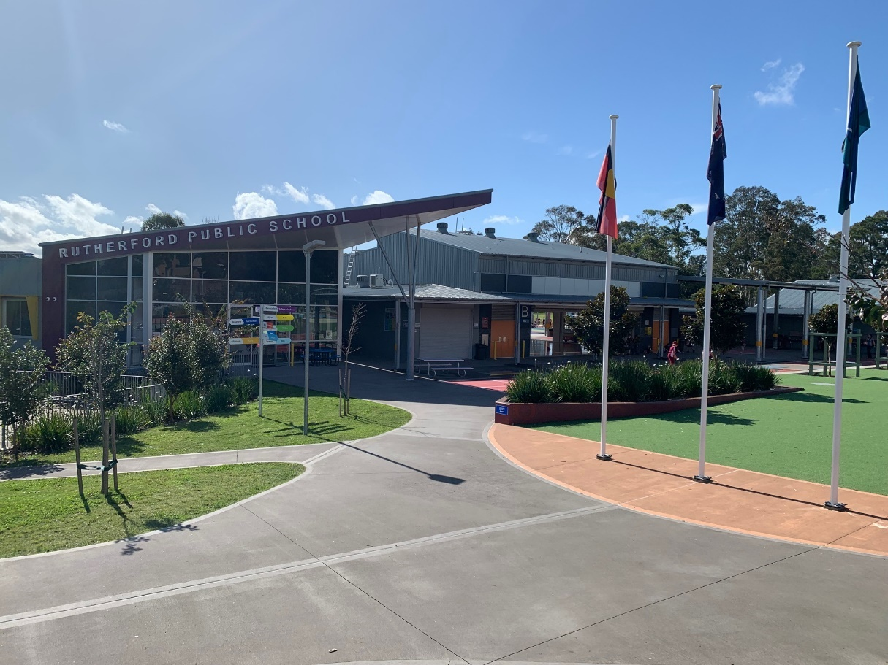

To be reviewed annually.

NSW Dept of Education’s Policy and Procedures

These school procedures are aligned with the NSW Dept of Education’s ‘[Enrolment of Students in NSW Government Schools’](https://policies.education.nsw.gov.au/policy-library/policies/enrolment-of-students-in-nsw-government-schools) Policy.

The NSW Dept of Education implemented its [General Enrolment Procedures](https://education.nsw.gov.au/policy-library/associated-documents/pd-2002-0006-01.pdf) on 22 July 2019.

# Intake Area

# A student is entitled to enrol at the local school that the student is eligible to attend if their home is within that school’s local intake area. Local enrolment applications can be found on our [school website](https://rutherford-p.schools.nsw.gov.au/about-our-school/enrolment.html).

# Parents may apply to enrol their child in the school of their choice. Acceptance is subject to the child being eligible to attend and the school can accommodate the child.

School intake areas are designated by the Secretary, Department of Education. The Rutherford Public School local intake area is below. Use the [School Finder App](https://education.nsw.gov.au/school-finder) for further information.

**Local Enrolment Applications**

Enrolment of students with disabilities

Rutherford Public School welcomes students with disabilities in our mainstream setting.

Our school also has a Support Unit comprising of 3 classes – two multi-categorical classes and one Autism class. A panel based at Maitland Office determines student placements in these classes. This panel assesses applications called Access Requests, and places students appropriately. Although Rutherford Public School does not take part in this process, we can inform and assist parents in how to navigate the process.

# Enrolment of students in our Opportunity Class

Opportunity classes located in government primary schools cater for academically gifted Year 5 and Year 6 students with high potential. These classes help students to learn by grouping them with students of similar ability, using specialised teaching methods and educational materials at the appropriate level. Parents normally apply when students are in Year 4. Students who are placed then attend the opportunity class full time in Years 5 and 6 at the primary school with an opportunity class. It is a two-year placement program. There is no provision to apply for Year 6 placement only.

The opportunity class placement process for Year 5 entry is administered by the [High Performing Students Team](https://education.nsw.gov.au/public-schools/selective-high-schools-and-opportunity-classes/contact-us). The process opens in April each year. You must apply online at: <https://education.nsw.gov.au/publicschools/selective-high-schools-and-opportunityclasses/year-5>

# Enrolment cap

The enrolment cap is based on Rutherford Public School having 36 teaching spaces for mainstream students. These spaces are multiplied by a factor of 23.1. This provides an enrolment cap of **832 mainstream students.** The students in our Support Unit and Opportunity Class are additional to our enrolment cap.

The enrolment cap tells us whether the school may or may not have the capacity to accept non-local enrolments. It is not a target or limit on the number of local enrolments a school can take.

Enrolment buffer

At present there is no enrolment buffer because student numbers are above our enrolment cap.

Residential address check

Rutherford Public School requires the following 100-point residential address check to determine the student’s entitlement to enrol at the school. In exceptional circumstances, principals may waive or vary the 100-point residential address check requirements when assessing a child’s entitlement to enrol at the school. If this is to occur, principals are required to seek the approval of the Director, Educational Leadership.

# **Non-local enrolment**

Non-local enrolment applications are only considered by schools that can accommodate the child below the set local enrolment buffer level. Non-local enrolment applications can be found on our [school website](https://rutherford-p.schools.nsw.gov.au/about-our-school/enrolment.html).

Except for enrolments at the commencement of the school year, schools that have not reached their local enrolment buffer level should only accommodate non-local enrolments into classes with available places.

# Criteria for non-local enrolment applications

The criteria, listed below, for the enrolment of non-local students has been developed after consultation with the school community.

* Students starting Kindergarten in 2023 with siblings already enrolled in the school;
* Recent changes in the local intake area boundaries
* Compassionate circumstances (compelling and exceptional)

When a non-local enrolment is accepted, the offer does not extend to siblings.

# Enrolment Panel

The school’s Enrolment Panel meets twice per term to consider all applications against the above criteria.

|  |  |
| --- | --- |
| 1 | School Executive - Chairperson |
| 2 | Staff member nominated by the Principal |
| 3 | School community member nominated by the school’s parent  organisation |

Waiting list

There is currently no waiting list.

# Appeals

Appeals against the panel’s decision need to be made in writing to the Principal. The Principal will seek to resolve the matter.

If the matter is not resolved at school level, the Director Educational Leadership will consider the appeal and make a determination. The purpose of the appeal is to determine whether the stated criteria have been applied fairly.

# Document History

|  |  |  |
| --- | --- | --- |
| Version | Author | Date |
| 1.0 | Andrew Brown | 7.9.20 |
| 2.0 | Jonathan Ridgway | 10.5.22 |